 Source Inspection Expecations for Suppliers

# Is Source Inspection Required?

Source inspection (SI) requirements are flowed down on individual Purchase Order Line Items (PO/LI). In the Procure to Pay Ship-To module the PO/LI Quality Status will be “Source Inspection Required”. After requesting source inspection, the status may change to one of the following, indicating that inspection is *not* required: Authorized to Ship - AIM; Authorized to Ship - QVP; Authorized to Ship - Waived

# Requesting Source Inspection

Source inspection is requested using the Procure to Pay “Ship To LMC” tab. Highlight the PO/LI, click the “Request LMC Action” button and enter the quantity to be inspected and the desired date for the visit. Make requests 5 business days in advance of the inspection need date to allow for inspector availability.

# Preparing for the inspection

LMSI is completed after your internal inspection, it is not a replacement for your inspection. Be prepared with hard copies of the following items:

* Purchase order (most recent revision)
* Lockheed Martin drawing
* First Article Inspection Report
* Certifications: Materials/Special Processes; the inspector will verify use of LM approved special processors
* All other documentation required by PO (CofC, Test reports, inspection results, etc.)

Verify that the quantity presented matches the quantity requested. Ensure that the material is in a well-lit area that is free of obstacles. The inspector may need access to measurement tools to verify dimensions, or they may ask to witness tests/measurements being taken.

# Inspection execution & closure

The source inspector will review all required documentation and inspect all characteristics in the LM SI plan including: Marking, Workmanship, Configuration, Documentation, First Article Inspection, Dimensions, Paint/Finish, Welds, Hardware, Damage, etc.

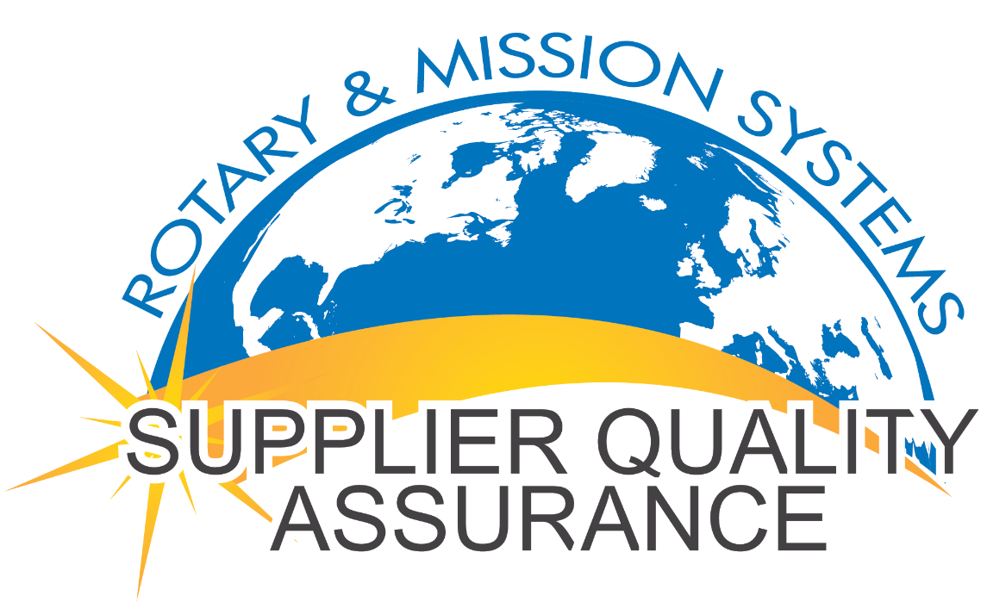The inspector will Accept or Reject the inspection lot that day. Rejected lots must be dispositioned by an LM Supplier Quality Engineer before inspection is re-requested. Accepted lots can ship.

Note: When the first lot is completed on the PO/LI, the Quality Status will not reset to Source Inspection Required - it remains “Authorized to Ship – Partial”. SI requests are required on further lots until the full PO Quantity is received.

Direct all questions to RMS Supplier Quality Services:

[Supplier-qa-services.fc-mst@lmco.com](mailto:Supplier-qa-services.fc-mst@lmco.com)